Speed Test in Student Hostels
(For Android Users)

A. Purpose
The test is to identify the possible reasons of poor wi-fi performance in student hostels, such as:
- Weak WiFi signal, Slow speed
- Frequent disconnection

B. Problem report

Personal Contact | Details
Date/Time:
Student Name and Student ID:
Hostel, Floor and Room Number :
Label of WiFi Access Point (Take picture of your setup such as in below)
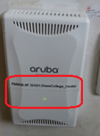
Connected SSID (CUHK, CUHK1x or eduroam/CSL/Y5ZONE)

Shutdown and turn on your computer and follow steps below | Expected Screen
- Goto Google Play and download Apps:  Office of the Communications Authority (OFCA) - 通訊事務管理局辦公室 | 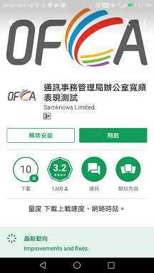
- Open wifi network  To ensure you are getting the nearest wifi signal, please turn off and again turn on the wifi of your device before carrying out the test. | 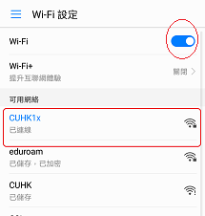
- Run OFCA apps on mobile  Perform simple speed test | - Click “Start”  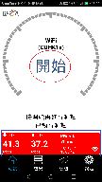  - Press “Press to Begin Test” button for start the test. and copy the screen like this.  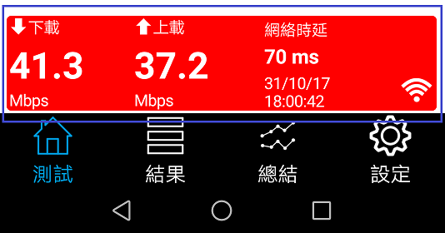
- Count the number of wi-fi users in your location if possible

C. Submit your Problem report
- Complete and save this file with “Hostel-Name-Wi-Fi-testdate-room-number”
- Submit it through ITSC Service Desk at https://servicedesk.itsc.cuhk.edu.hk/

End

